THE WAY OF SANT'ANTIOCO IN THE SULCIS

The Cammino di santu Jacu-Santiago in Sardinia was designed and traced starting from Sant'Antioco, saint patron of Sardinia, "the holy Moor who came from the sea", to arrive in Cagliari, the capital of Sardegna, and then following the Central Axis up to Porto Torres for shipping towards Barcelona, walking the Catalan-Aragonese Way to Logroño and the Camino Francés to Santiago de Compostela.
Sulki, the ancient name of this island in the south-west of the large island of Sardinia, has always been a landing point for navigation in the Mediterranean Sea. But also, the port from which the mineral and food riches of this land were exported, exploited over the centuries by various settlers and occupants, who have left their mark, before and after the advent of Christianity. At times depopulated due to attacks by Barbarians pirates, at times a penal colony for condemned Christians from the Maghreb lands and southern Italy, on which the saint who came from the sea, Antiochus, who will give the island its name, stands out right here.
The cult of him remains over the centuries and the discovery of his relics in the Middle Age will perpetuate it until today, despite various disputes now lapsed with Iglesias and bishops.
The historical link with Santiago di Compostella is testified by the tables of 1466 and it is for this reason that our saint James Way begins here, at the Basilica of Sant'Antioco.
It is thought to extend the specific itinerary to the historic route of the annual pilgrimage between Iglesias and Sant'Antioco.
We have operated voluntarily for the last 12 years and opened the way to walking, cycling and horse riding. Good walk!
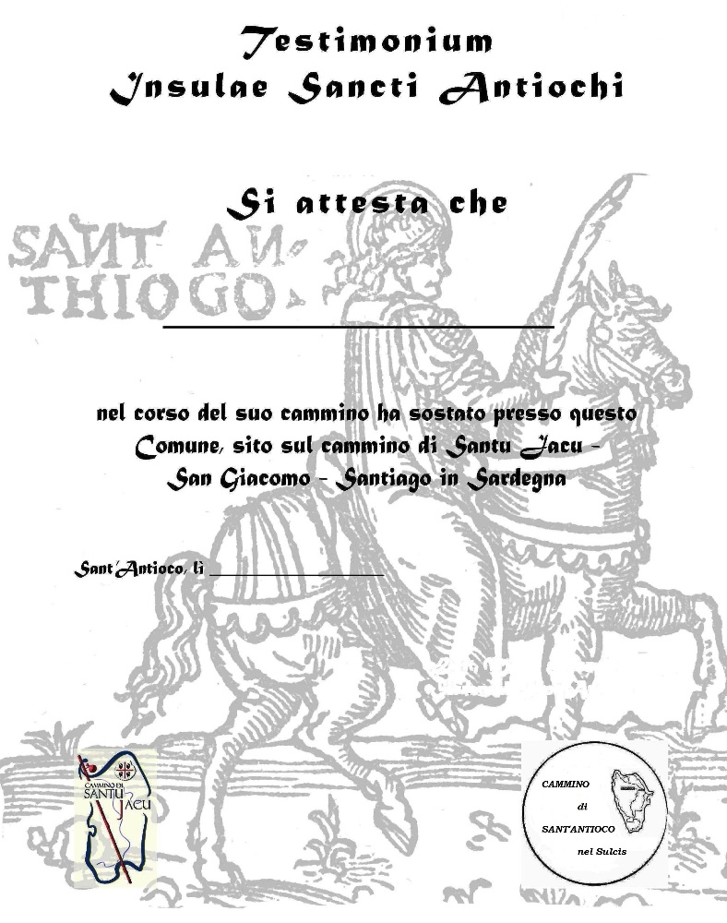
HOW TO ARRIVE HERE
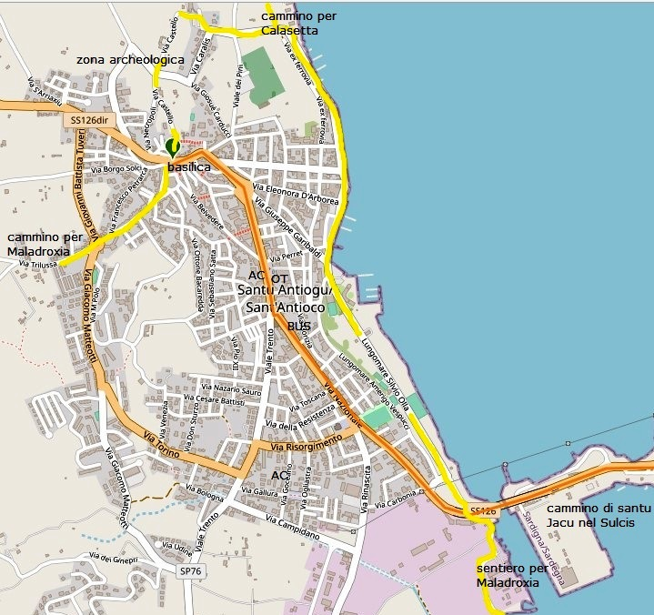
We recommend taking the daily bus at 10.15a.m. or the weekday bus at 13.05p.m. towards Calasetta (Piazza Repubblica is the bus stop in Sant'Antioco) or the train from Piazza Matteotti in Cagliari (or directly from the airport at Elmas) to the station Carbonia Serbariu and then the bus to Sant'Antioco.
Other possibility: rent a car or private bus

NOTES and ABBREVIATIONS: dx right; sx left; SS national road; SP provincial road; AC accomodation (often as a donation, free offer); AJ hostel; B&B bed and breakfast; AG agritourism; OT tourism office; MP half pension; BR bar restaurant; HR hotel restaurant. NB: the path is marked with yellow directional arrows outside the towns and blue stickers with shell and arrow stylized in yellow in urban centres. The X indicate directions not to take. When there are no indications, you must continue straight.
The local path touches the most important points of the island (about 68 km which can be divided into four stages). Tracks GPS Wikiloc | Percorso Cammino di Sant'Antioco TUTTO
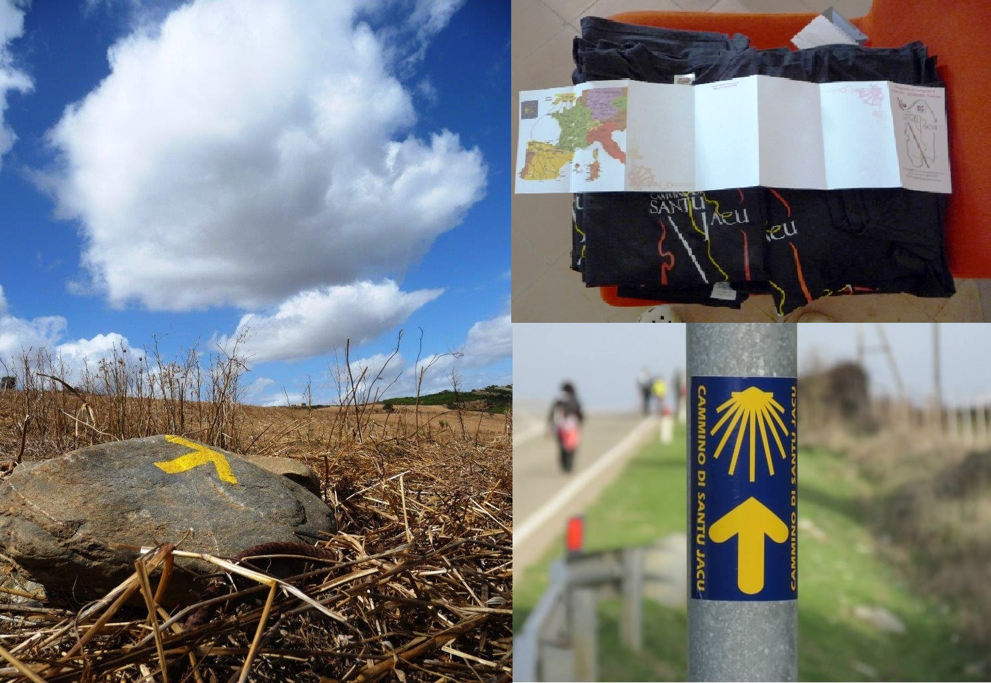

THE ORGANIZATION

CONTACTS: Our contacts, Marinella Serrenti (3407625172) and Marina Scibilia (3925132245), p/o Isola dell'Ottica, via Roma 26, can inform you of the way. Credentials, T-Shirts and Testimonium available.
Cammino di Santu Jacu T-shirts: you can buy them in the shop “Isola dell'Ottica” Marina Scibilia, for €10
- Affiliated accommodation for pilgrims.
*AC possible for a people, Marina Scibilia 3925132245 p/o l'isola dell'ottica, near the municipal Infopoint/
*B&B with special agreement “il Nido” Francesco Lai and Simona Gatti, pilgrims of Santiago at €25 tel 3497301923 via Nazionale 110/
*Bed with breakfast at €20 at the Muma Hostel, with special agreement, tel 3911377062/ 0781840070, Lungomare Colombo 25/
*B&b Serrenti Marinella, 0781840901- 3407625172 in the country, with all facility/
*Other lodgings: out of the high season, normal prices.
* Maladroxia: for the moment no conventions and accommodations opened only for the high season, and with prices not for pilgrims.
* Calasapone: no structure affiliated with us, but there is a campsite at a low price for an igloo-type tent pitch, and holiday homes in the surrounding area which, depending on the season, are obviously more expensive than any affiliated accommodation.
In case of difficulty, for accommodation, logistics or information on the route, call the referral Marina Scibilia Tel. 3925132245
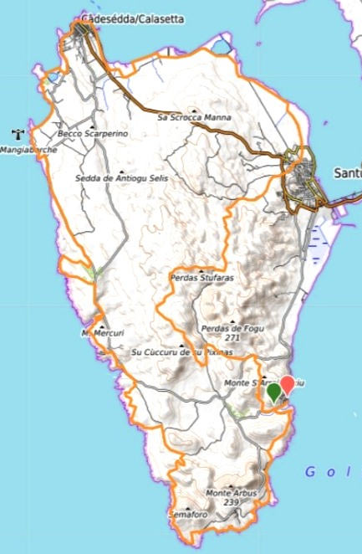

The PATH
The path is waymarked with manually painted yellow arrows (generally on rocks, on the ground, on low walls, signs) and in some points with stickers of the Camino di Santu Jacu (on poles, metal signs).
Due to the conformation of the territory and/or the vegetation, it was not always possible to place an arrow at the exact turning point, so look before and after the crossroads to make sure you are taking the correct path. The curved or angled arrows sometimes do not indicate to turn immediately (in fact you will not find any path at the point), but they were placed in advance of a crossroads where it was impossible to signal. Sometimes we have put an X on the wrong way and you must come back. In some areas with a predominantly sandy bottom and few rocks, it is easy to walk instinctively following the paths in sight, there will only be "recalls" with approximately rounded yellow "stamps", so as not to smear the cliff, or nature in general.
NB: In the part from Calasetta to Sant'Antioco, there are also bidirectional arrows because the path corresponds to the Cammino di Santu Jacu, which can be done in both directions.
Sometimes, and only in this stretch, we have also marked with "S.A." for clockwise arrows.
It will be very useful to have the paper or digital descriptions, for any doubt; they are accurate.
- The variants adventurous are not marked with arrows (except that of the wood, in the first stage) they are only explained on the description. If it seems difficult, go back to the standard path.
- The stages are 18km, 18km and 29km, possibly the last can be divided into about 17km + 12km, stopping in the village of Calasetta, where there are many accommodations.
- The elevation gain of the three stages is 400m+, 450m+ and 250m+, the final stage is in fact long, but no difficult.
- Above all, the first two stages are made up of more or less impervious or bumpy paths, the difference in height overall is not much, but the paths are not always smooth. However, in the third stage there are also several parts in asphalt, so it is difficult to estimate a time average distance with the normal methods adopted for hiking.
- In the hot season it can take longer because you will certainly lose some time for a few swims, or for a beer in a kiosk, but it will not be wasted time.
- Recommended season: all year /
- In the cooler seasons it is easier to walk, even if there may be sections with clayey, sticky mud, but there are no critical points with insurmountable fords.
- In the hot season (from mid-May to October) you can suffer from the high temperature, but you can swim.
Carry sufficient water and food in all seasons. In the high season (June-September) we will certainly have the heat but we will also have an easier time finding accommodation (otherwise closed) and above all water and various refreshments, in the seaside resorts of Maladroxia, Coa Cuaddus, Calasapone and Calalunga.
It is important because there are no springs or fountains on the way.

HISTORY: A rather rough area, the hills reach 250m above sea level, reaching the coast with high and jagged coasts, few beaches. It has a marina and a commercial port. The city was founded by the Phoenicians and continued into the subsequent Punic and Roman periods. After the Byzantine conquest its fortified system was strengthened with the construction of the Castrum. Starting from the eighth century the city began to be seriously damaged by the incursions of the Arabs and went depopulating and decaying and during the twelfth century the seat of the diocese was moved to the safer Tratalias. The city was abandoned and the territory became the property of the bishop of Iglesias who kept alive the memory of the cult of the saint whose anniversary was celebrated annually. However, it was a precarious presence due to the incursions of the North African corsairs, who also made it their base. During the second half of the 16th century, the first coastal defense and lookout towers were built and the area began to be visited on a regular basis again. At the beginning of the seventeenth century, the excavation campaign promoted by the archbishop of Cagliari in search of the relics of the saint Antioco seemed to bring the ancient site back to life. Thus, the first medaus and boddeus arose, while a new inhabited nucleus was being built around the ancient church. In 1758 the island was ceded to the order of Saints Maurice and Lazarus who established a commandery there. The territory was divided into two parts, the one with the greatest extension in the center developed rapidly in the area of the old city around the church; that of lesser extension to the nascent Tabarchina colony of Cala di Setta. In 1848 it became part of the administrative division of Cagliari and from 1859 of the province of the same name. During the nineteenth century the economic importance of S.A. it grew with the development of the mining activity; in 1936 the port was built for the transfert of mineral products. After the end of the Second World War, with the progressive closure of the mines, the port declined due to the development of the industrial area of Portovesme. In recent decades, its economy has started to grow again thanks to agriculture and viticulture, but above all to tourism. The territory preserves evidence of the presence of man from the period pre-nuragic with the domus de janas of Pruinis, a complex of chamber tombs dug into the limestone, and Grutti 'e Acqua, attributable to the culture named Ozieri. The remains of a Nuragic village and a nuraghe located in the current inhabited centre, not far from the eighteenth-century fortress, belong to the Nuragic period. The archaeological testimonies of the Phoenician-Punic period are those of Sulci, the city founded by the Phoenicians between the 9th century BC. and the VIII B.C. Later, with the settlement of the Carthaginians, the city became a port for the lead extracted in the Iglesiente. It was joined to the mainland by a 3km long isthmus filled with materials between some alluvial islets, fortified, and during the Punic wars it played an important military role. The current center extends over part of the ancient Sulci, of which the necropolis remains, a short distance from the basilica to the north of the center, with Punic tombs, including one with a painted arcosolium dating back to the II-III centuries AD; in some the kit has been preserved as it was found during archaeological excavations. To the north of the necropolis is the Tophet, a sacred site where the sacrifices of the firstborn to the goddess Tanit took place, a widespread custom among the Punics, in a large space surrounded by rock spikes which is accessed by a sacred road that the nocturnal procession traveled along in the days of the sacrifice (ritual of the Molk). In addition to the altar, excavations have revealed the presence of dozens and dozens of small stelae, small urns and a pile of ashes and bones that document the cult (the ashes preserved in the Tophet belong to children who died a natural death: the cremation fulfilled a ritual and propitiatory function). Passed to the Romans, the connection to the mainland was completed with the construction of a bridge with two arches that crosses the last arm of the sea. The city in the 1st century AD it was erected as a municipium and, starting from late antiquity, it was the seat of the diocese of Sulci and of the nascent cult of Sant'Antioco. In addition to the bridge, the remains of the road connecting with Sardinia, the tombs and the source of Is Solus in the heart of the urban center date back to this period.
In the centuries of the late Roman Empire and after the Byzantine conquest, the basilica, the martyrium and the catacombs remain. The basilica was the seat of the bishops of Sulci until the transfer of the diocese to Tratalias; it was built in different eras and its structure is difficult to read chronologically, in the absence of adequate documentation. It consists of a domed central body which overall suggests the basilica of San Saturnino in Cagliari and can be traced back to the 6th century. Around this body, between the 9th and 10th centuries, a free cross building developed with a nave and three naves with barrel vaults which incorporated an ancient martyrium. When the building was then handed over to the Vittorini, religious order, during the 11th century, it was restructured in Roman style of which some elements remain; finally at the beginning of the 17th century, in the fervour for the discovery of the body of saint Antioco, which occurred in 1615, the building was enlarged and the facade assumed its current configuration. In the basement of the church there are still the catacombs dating back to the time of the oldest diffusion of Christianity on the island; they can only be visited to a small extent and contain traces of paintings, inscriptions and preserve the place where Sant'Antioco would have spent many years. Other buildings from more recent periods are the Monte granatico and the Archaeological Museum. When the archaeological excavations began, a first Antiquarium was set up in via Castello in two small rooms in which the most interesting collections were exhibited. At the entrance, the Museum shows the two large tuff lions that once stood at the entrance to the city; the exhibition itinerary includes 8,000 of the 15,000 exhibits owned by the institution, a document of great importance for the city and for the Phoenician-Punic civilization in general. In the upper part of the town is the fortress complex, a set of ruins of great importance for the history of the city. In the most dominant position stands the fortress proper, a building built in the 18th century to defend the village from Barbary raids. A short distance away, in a less elevated position, in the area where the Antiquarium once stood, the remains of the north-western fortifications of ancient Sulci and of a porticoed building built in the late Republican age on a previous Punic building have emerged. Outside the town is the Cannai tower, built in 1746 more than 10 km away (a two-story truncated cone-shaped building in excellent condition. Inside there are two domed rooms communicating with an internal stairway). The tower was equipped with an adequate number of artillery pieces and served by a garrison of soldiers and artillerymen.
FESTIVALS AND POPULAR TRADITIONS: The event that best summarizes in itself the traditions of the ancient center is the feast of Sant'Antioco. The celebrations in honour of the martyr, which take place fifteen days after Easter, would seem to date back to 1519 and are important not only for Sulcis, but for the whole of Sardinia of which he is the patron. A rich program of Sardinian dances and songs takes place around the procession, with a poetic competition. Another festival is the one in honour of the Madonna di Bonaria, which takes place on the first Sunday of September.

THE TRACKS of the SANT'ANTIOCO WAY (68km)

*Sant'Antioco-Maladroxia (about 17.5 km)
Wikiloc | Percorso 1a tappa Cammino di Sant'Antioco
- SANT'ANTIOCO – MALADROXIA
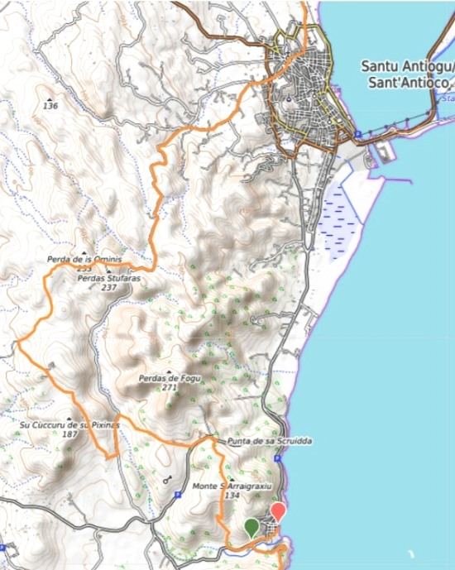
It starts from the Basilica, where the relics of the Saint are kept. Proceed to the left towards a narrow alley which is the beginning of Via Manno, which then widens and bends towards the right. Proceeding along this road, you come to a small roundabout and nearby a traffic island with a stone sculpture, and continue straight on, in Via Trilussa.
Here begins a long-paved road which soon leads out of the village towards the countryside, with little traffic and pleasant to travel.
NB: About 200 meters from the traffic island with the sculpture, there is an arrow on the left marked as A (accomodation), which leads into a dirt road and after about three hundred meters we will go right again, still following the A. Here, on this short in a rural stretch there is the agreed holiday home for pilgrims, Marinella, a volunteer of the Association (tel. 3407625172).
NB: if we don't have to stay overnight in Marinella, at the first A we go straight on for about 5km, ignoring the detour on the dirt road.

--- Variant for adventure lovers (extends a little only because it's a little slower to travel). Recommended for the more experienced and for those who make the journey in the period with more hours of light: passing by the dirt road towards Marinella's house, just before coming out onto the asphalt, on the left we find an inviting cement road first and then a dirt road, indicated with a yellow arrow and VA (adventurous variant), which seems to end after less than a km, but in reality you can continue, at the end, to the right and then immediately to the left, along a real goat path, but legible among the scrub, with various ups and downs , sometimes a bit slippery, especially in the first part when the climb begins. Ignore the only possible left turn, which depending on the time of year you can't even see because the vegetation blocks it, and continue following the uphill path to the right. After various ups and downs, the single track enters a real Mediterranean scrub forest, an enchanted, shady and humid forest, which you follow following arrows and yellow dots until you come out again on the paved road as before, and following the arrow we turn again left, to continue on the asphalt for about 1.5km. ---
Here we can proceed serenely for 3km and then turn right onto a dirt road, with some parts cemented, where the slope becomes more difficult. After a few hundred meters, where a small hillside rises to the side of the path which prevents us from seeing the Island of San Pietro (which we had until just before), in correspondence with a pile of gravel on the right side of the road, you can see above two large rocks shaped by the wind, known as "Sa Perda 'e s'Omini", which can be reached in five minutes by following a network of small paths along the low scrub. It is a brief digression that can be liked, without stretching much.
Once back on the main path, we continue following the yellow arrows for a few more km. We will find several crossroads and we will follow the arrows.
We will then arrive at a crossroads of paths and we will still have to turn left, onto a wide dirt track suitable for vehicles, which starts to climb for a while, up to the square of the archaeological area of Nuraghe Corongiu Murvonis (an unmanned and interesting area for a "adventurous" detour of about half an hour, and also an excellent place for a stop on the flat rocks with a beautiful view towards the west coast, and beyond).
NB: we are more than halfway here.
We will then return to the wide track which we follow without turning off until we reach, after a long descent, a sheepfold and then the road, narrow and with very worn asphalt. Here, we take a left, and after 2-300m we follow the arrows on the right, crossing a small ford that is almost always dry, entering a shaded path which, climbing gradually, will take us, past a farmhouse, to the provincial road, de which you have to walk, to the left, only 200m.
Then we turn right uphill and we are again on a path.
We continue on this narrow path going up and then downhill for a long stretch to the paved road that goes, turning left, to the Maladroxia beach. Along the downhill part of the path, it might seem that we are proceeding in the opposite direction to the paved road that we will have glimpsed, but the path is right!
The path continues, for the second stage, at the beginning of Via Cala Bianca, while proceeding straight we will go to the beautiful beach (arrows with M for sea= mare)
--- Road variant for those who are tired, or for those who also want to see two other coves: after the farmhouse, come out on the paved road, instead of taking a right on the aforementioned path, proceed along the provincial road downhill for 10' up to another path (it can be recognized by the yellow arrow with VM- sea variant), which will quickly take us to the beach of Su Portixeddu. From there, take a right onto the paved road and after a quick look at Su Portixeddu Acuau (also known as "the basins") you reach the seaside village of Maladroxia, with the beach of the same name, known for its underwater thermal waters on the left side of the beach. ---

*Maladroxia- Calasapone (about 18.4 km)
Wikiloc | Percorso 2a tappa Cammino di Sant'Antioco
2- MALADROXIA – CALASAPONE

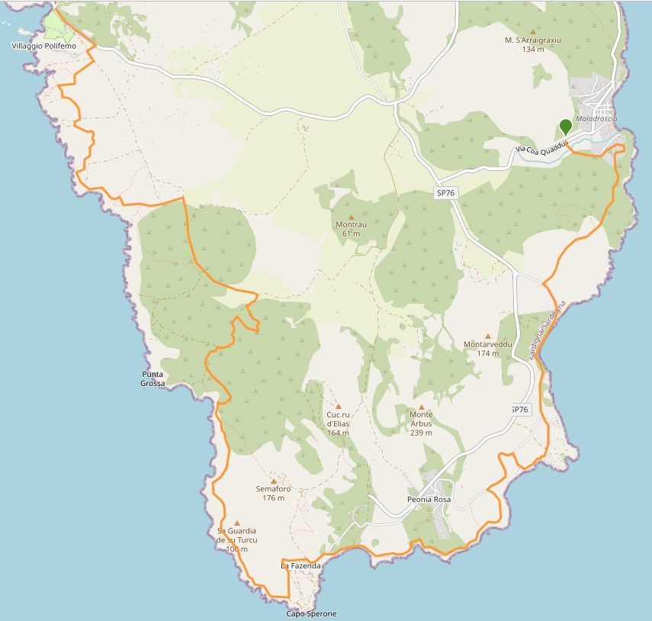
In the high season, Maladroxia beach offers many services, and has been awarded the Blue Flag for some years.
To resume our journey, we have to go back from the beach and, after 100 m from the parking lot, turn left onto Via Cala Bianca (dirt track), which goes up next to the villas on the right side of the bay, to reach the entrance to the path " institutional” Serra Is tres Portus. We must continue straight on this path, ignoring the two turns to the right which only lengthen, being the entrance and exit of a bend in the path itself.
After about 1.5 km you reach the next valley, that of the beautiful double beach of Coa Cuaddus, and turning left onto the asphalt, we will be near the beach. Here too, in the bathing season we find refreshment points and services, and for 2022 the Blue Flag has been recognized.
We can choose to walk on the beach, even if it is not always possible to "wade" towards the second one, and therefore we will be forced to go up and eventually go back down to the beach. At the end of the second beach, there is a small steep path that leads back to the road, where we turn left; or to continue on the asphalt, enjoying a beautiful panorama.
.
--- Adventurous variant: after having emerged on the asphalt, after about 150/200m you can "instinctively" access small paths towards the coast, at times only hinted at, and then walk almost along the shore, until you reach the cliff a beautiful small pebble beach and then the beautiful Torre Canai, dating back to 1757. Here there is a path that surrounds it and allows breathtaking views for those who dare to jump over the wall. From here, following the dirt road used by cars (in the summer it is a parking lot), you reach the main beach of Turri, usually made of pebbles. ---

We will reach the dirt road for Torre Canai and Turri beach on asphalt. You will also find yellow arrows indicating to continue on the asphalt, for those who are not interested in the following passage on the paths and beaches of Turri.
However, it is advisable to turn onto the dirt road for Torre Canai, where after the villas, turn right following the dirt road/parking just mentioned, to reach Turri beach. Go up to the right along a panoramic path, which overlooks the next beach from above, thus reaching the paved road again that we had left.
We continue left for a while until we find the yellow arrow on the left which leads onto a path. From here, we pass a beautiful green promontory with some glimpses of hidden and little frequented coves. Continuing on the path that runs alongside the sea, even if you move away from it a little (ignore deviations to the right), we will arrive at a pebble bank (with the pine forest of the Peonia Rosa residence behind it), from which a concrete path ascends, to be followed always ignoring the cemented detours to the right, unless you want to refresh yourself in the shade of the beautiful pine forest, before continuing. Carefully following the arrows, we will turn left twice, always following the coast until we reach the beach of S'Acqu'e sa Canna, with the path on the back that reaches the paved road.
We are located in Capo Sperone. We turn left, along a beautiful recent fence, and at the end the road turns into a bumpy path and climbs alongside an old disused residence. At the top right we can admire the beautiful ruin of the Semaforo della Marina from a distance. We enter a path that turns right and follows the coast, for an up and down of wonderful glimpses of the cliff (be careful!), until we reach, we see the Grotta delle Sirene in the distance, in the bay of Portu Sciusciau. Here we are about halfway through the stage.
Once we get to see the bay up close (ignoring the junction on the right indicated by an arrow), we go back to resume following the arrows and slowly go up the hill on the left up to a nice open path to the archaeological site of Grutti Acqua . Here, at the height of a large dwarf palm (at the moment it invades the access a little, but the path is visible and there is an arrow) we will turn right to go up to the Nuragic lake and then go back down (there is a point at where there may be a "vegetable plug" at the height of the passage marked by the arrow: get down and proceed) to return to the path between dry-stone walls which leads to a ruin used as a sheepfold. Here we will have to open and close the rudimentary "network gate" if closed, or leave it open if we find it open. It is good practice to follow this precaution because livestock circulate and, if it is open, it must remain open, and vice versa.
For those who are not interested in going up to the lake, you can continue straight ahead, instead of turning at the height of the dwarf palm, and simply reach the sheepfold.
Once out of the sheepfold, we are on a wide dirt road and we go left, until we pass near Sa Corona de su Crabì, a large ridge of rocks full of small caves, perpendicular to the coast, which offers an excellent shelter to the shade for a break, in the rocky ravines that have formed there over time, thanks to the action of the wind and bad weather.
Adjacent to the ridge is the beautiful Tomb of the Giants Su Niu de su Crobu.
Continuing on the dirt road, after a while we turn left onto the path that descends along the coast towards the upper part of Baia Mezzaluna, to continue along the rocky coast in the direction of Is Praneddas with its Arco dei baci and natural swimming pool. After this panorama, leave the lower part of the cliff to climb higher and continue on a sort of plateau up to Portu su Casu. We reach the dirt road, where we turn left and continue up to the paved road for Calasapone, another beautiful beach surrounded by flat cliffs, comfortable for bathers, and with services and refreshments, in high season.
*Calasapone-Calasetta (about 19 km):
Wikiloc | Percorso 3a tappa 1 Cammino di Sant'Antioco
3- CALASAPONE – CALASETTA
From Calasapone we proceed to the end of the beach on the road, then turn left onto an access path to the same, and then go right up the escarpment, which allows us to follow paths instead of asphalt. At a certain point, these paths almost run parallel to the road and the parking lots, and we will also find access to the beautiful Cala della Signora; if you want, it may be worth going down for a swim or a photo.
We arrive at the crossroads on the left for the I Ciclopi residence, and we follow the asphalt up to its entrance with a bar, where instead of entering it we turn right, onto a path that winds its way in the first section between this residence and the garden of a Hotel, but which shortly after develops on ups and downs along the coast, where following the arrows we ignore the accesses to the sea.
We get to see Cala Lunga from above, a beautiful bay in the shape of a fjord, set in the fragrant Mediterranean scrub.
Leaving the alluvial valley that forms the beach, we turn left and continue on a driveway, which has a ford (dry in summer) and then becomes paved. After a demanding and sinuous climb, we find ourselves on a sort of plateau, with the distant sea on our left.
We arrive at a pine forest and leave the road to turn left along the downhill path to the cliff. Here we are at the Mimoseto, a fascinating cliff with caves and a small natural pool. The path runs behind the cliff on a sort of ledge midway up to a point where arrows will tell you to go right, away from the coast again. Go up next to a reforestation of pine trees, which remains on your right and, before a ruin used as a sheepfold, the path turns slightly to the left and then immediately to the right. It is possible that we find a low "network gate", which can be climbed over. It is only for the cattle and we can pass, then we will continue going up again near other pines, until we return to the paved road of the plateau.
From here, we have about 2.5 km on the asphalt, with breathtaking views of the Nido dei Passeri stacks and the Mangiabarche lighthouse. Then we turn left again onto the asphalt at the height of a cluster of country houses and further on left again towards the sea, on the paving that goes where we can look out over the stacks (if you suffer from vertigo, be content with the first view!) . From here, we follow the paths to the right, more or less one path is as good as another, we proceed instinctively with the sea on the left, you will still find some arrows or yellow signs for comfort. Finally, we reached the track for the Tonnara di Spiaggia Grande. When you reach the signs indicating the Tonnara we enter to walk on the beach to the end, and then follow the paths in the scrub along the sea. We find some yellow signs of comfort up to a paved road, which we cross, and we continue on the dirt road. When it ends, you come out on the coast: from here, pay attention to follow the yellow signs to go along the back of the coast between the scrub and some rocks, until you enter, paying particular attention to the yellow signs, a very narrow and shady path between the trees and a few cottages to then come out onto another paved road, where we will turn left to the Salina beach.
NOTE : if you find yourself in a clearing among the trees surrounded by fences, go back the way you came there, and you will find the right path shortly after.
We are more than halfway to Calasetta, where you can stop. Even the Salina beach is to be covered to the end, and exit onto the wooden platforms as far as the parking lot and the road, continuing again to the left on the asphalt. After another couple of km, you arrive at the village of Calasetta, where the arrows tell us to go down to the beach, and then climb the steps to the road, which leads to the highest part of the village.
We turn left at the first level of the ladders (continuing on the other ladders we go to the Tower) and after the panoramic curve we go down to the left on the belvedere that goes to the port. We walk on the quayside of the marina to the Ferry Port;

4 stage: CALASETTA- SANT'ANTIOCO km 12
Wikiloc | Percorsi nel mondo
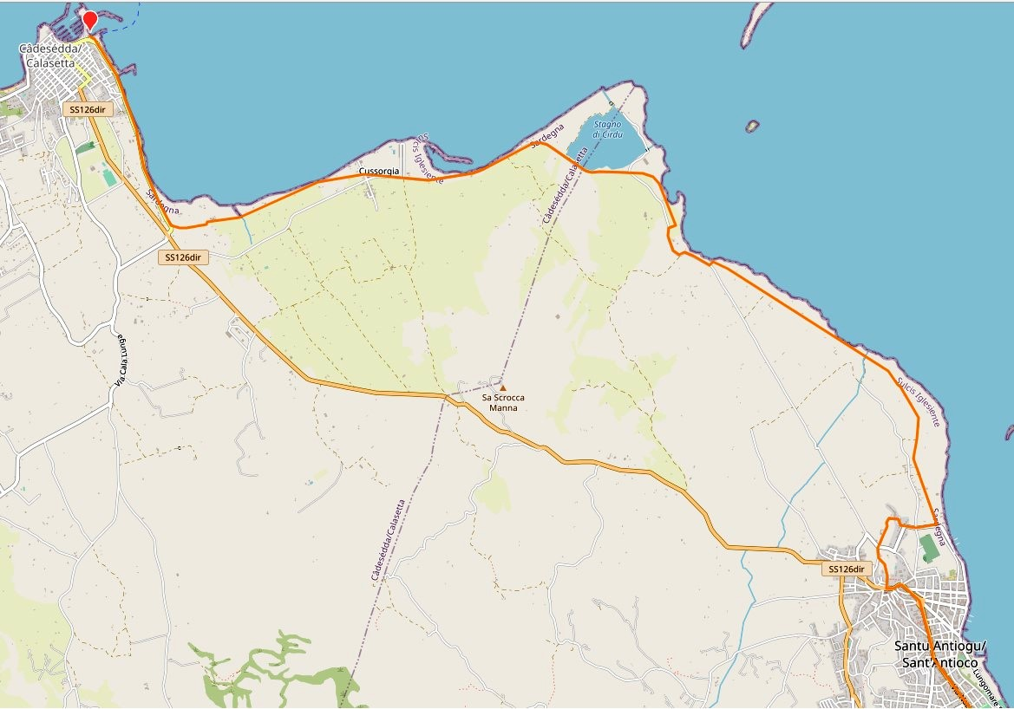
We continue in a northerly direction (right) on the road that runs alongside the sea, for about 1.5 km to turn onto a path whose entrance is barely visible (but indicated by arrows) and takes us to a countryside area and villas near the sea . From here we continue to the right near the houses and then we find ourselves on the paved road, continuing to the left. After a few hundred meters we turn into a "private road" (the ban is only for cars) for access to the beach and continue walking along the beach to the right up to the seaside resort and village of Cussorgia. We take the paved road again, and follow the arrows which can be bidirectional (sometimes even in the opposite direction, because the Santu Jacu Way passes on the same route and is bidirectional, while the one for Sant'Antioco is only clockwise). We keep in mind that we are going clockwise. We marked it with S.A. near some arrows, compared to CSJ, which we use on the entire Santu Jacu Way in Sardinia.
Along the road there will also be some arrows inviting us to take a right onto a dirt road, which rejoins the asphalt again a little further on. To you the choice. After an S-curve, you will find a detour on a path towards the sea which takes you onto the quiet dirt road, known as the "cyclable", along the route of the old railway from Sant'Antioco to Calasetta.
A) we can choose to continue along the cycle path to the centre, along a paved road that continues crossing Via Insula Plumbaria to become Via dei Pini, after which we will follow Via Dante Alighieri to the right and then the large Via Regina Margherita
B) from Via Insula Plumbaria, turn right to go up to the Archaeological Museum and the Tophet, then towards the Savoy Fort and arrive at the Basilica of Sant'Antioco Martire, where we will have finished our Way!
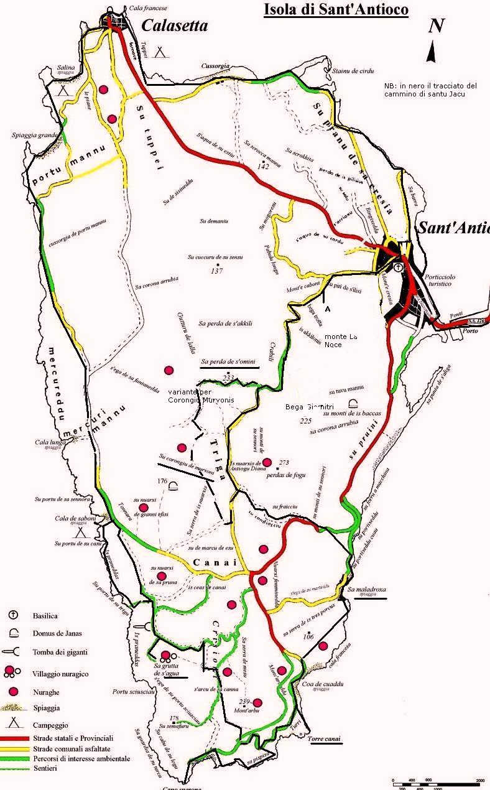
NUTRIMENTS FOR THE SPIRIT

Municipal library-Piazza de Gasperi, 1- Tel 0781 83132

Museums:
Municipal historical archive, Via Castello, 2 Tel 0781828027
Archaeological Museum: tel 078182105- 3897962114 tofet@tiscali.it https://mabsantantioco.it/
Ethnographic Museum, Via Necropoli, tel 0781800596 – 3890505107 https://www.archeotur.it
info@archeotur.it
MuMA Sea Museum, Lungomare Cristoforo Colombo, 25 Tel 0781840070 | 3911377062

In the Basilica it is possible to visit the catacombs (formerly ancient Phoenician-Punic hypogea) of the first Sardinian Christians followers of the Saint, and his Tomb (9h-12h 15h30-17h)

TEXTS to read:

*S. Antiochus from first evangelizer of Sulci to glorious Protomartyr "Patron of Sardinia" by Roberto Lai and Marco Massa - Editorial realization Arciere Edition, Sant'Antioco edited by Roberto Lai and Marco Massa- With contributions by Maria Giulia Amadasi Guzzo, Antonio Maria Corda, Roberto Coroneo, Elisabetta Curreli, Rossana Martorelli, Alessandra Pasolini. Walter Massidda iconographic collection. Graphic design and layout Franco Nieddu Printing and installation Grafiche Ghiani - Monastir (CA)

*Carlo Pillai- The glorious S. Antioco martyr from Sulcis and Sardinian saint- Marquisate of Villasor- © 2006 Municipality of Villasor Department of Culture Municipal Library, Second edition: SANTI FESTE TRADIZIONI June 2006

*Preface of the Annals by Prof. Marco Buonocore
The memory of Antiochus, protomartyr patron of Sardinia

Sant'Antioco Useful numbers
Pro Loco: P.za Repubblica 078182031
Tourist Association 0781840592
Municipality of Sant'Antioco - Corso Vittorio Emanuele, 115 - 09017 - Tel .0781 803001/2/3/4 - info@comune.santantioco.ca.it Tel. 07818030217

BUON CAMMINO NEL SULCIS !

Amici del Cammino di santu Jacu (AdCSJ) www.camminando.eu
Mail: amicisantujacu@gmail.com
Facebook: group “amici del cammino di santu Jacu” 