Useful information

Credential
If you want to follow the way of santu Jacu like a pilgrim, you need the Credential. To request it, it's necessary to contact the "Associazione Amici del Cammino di Santu Jacu” by email at amicisantujacu@gmail.com, or by phone +39 3331032822; the better is contact the referrals in Cagliari, Porto Torres, Olbia, Sorgono, Mandas, Sant'Antioco in Sardinia or Cernusco sul Naviglio (Milan). Patches and t-shirts of the Cammino are also available.

Accommodation
Several possibilities could be suitable for the different needs of pilgrims. Besides the basic accommodation at parishes or municipal and private structures, there are recognized hotels and B&B. A complete list of the available accommodations can be consulted and downloaded from our website: http://camminando.eu/wordpress/in-italia/il-cammino-di-santu-jacu/elenco-degli-alloggi/

Way Marks
For this Way we used the classical Jacobean shells and yellow arrows or the stickers in the villages.

Cartography - GPS tracks
Information and cartography are available on the website of Santu Jacu: www.camminando.eu.
GPS traces can be downloaded from the website and also be consulted on Wikiloc: https://it.wikiloc.com/ on CSJ amicisantujacu

Testimonium
As elsewhere, also in Sardinia a simple instrument as the Testimonium is necessary in order to be updated on presences, to know who walks it and to release a certificate which is both a keepsake and a testimony of the Cammino.
At the moment they are issued in Mandas (Testionium Mandarensis), Cagliari (Testimonium Kalaritanum), Porto Torres (Testionium Turritanum) and Sant'Antioco (Testimonium sancti Antiochi).

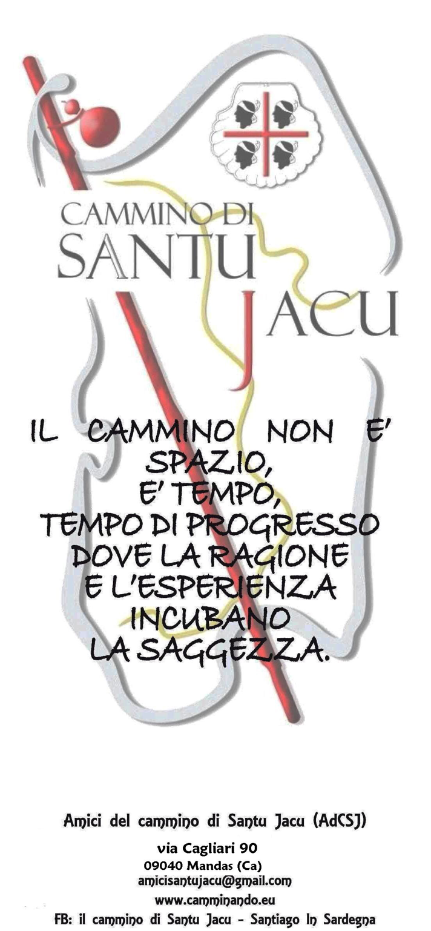
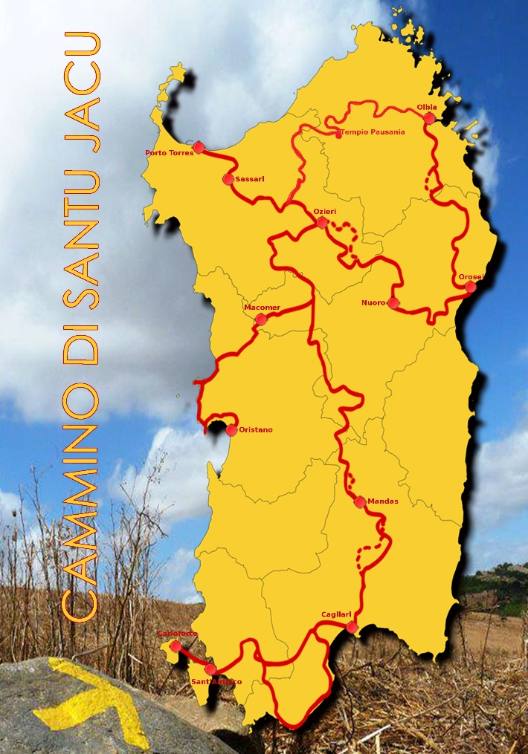

"The glorious Apostle Saint James leaved Jaffa and came to the island of Sardinia; and from there to Spain…" (Breviary of the Armenian Patriarch of Jerusalem, 1054)

Although there are few historic proofs about the passage of the Apostle James the Major in Sardinia and they are mainly ascribable to the passage mentioned in the Armenian breviary dated 1054 and also to the documents of Sant’Antioco-Sulki (1466), the cult of the Apostle is widespread in Sardinia and it's still present in more than 30 churches. It has its roots in popular culture, both as defender from lightings, with Saint Barbara, and as defender of the good death, taking the souls towards the Milky Way, as proved by the Jacobean confraternities still present in Cagliari and Sassari.
Actually, there was a lore that the hoofs of his horse produced thunders and lightings, and the Saint himself was called "Boanerges", "son of the thunder", because of his impetuousness, as demonstrated by the sardinian popular invocation:
"Saint Barbara and Saint James, you who have the keys of the lighting; you who have the keys of heaven, don't touch other's children in the villages neither in the countryside; Saint Barbara and Saint James". Instead, the figure of "Santiago Matamoros" is only present in Mandas in the marble bas-relief of the Major altar, ordered by the Spanish Duke who reigned in that period over about one third of Sardinia.

The Way of Saint James (santu Jacu) in Sardinia

The project to create the Way of Santu Jacu was conceived at the end of 2009, by a little group of pilgrims with experience of the Spanish "Camino de Santiago". Our idea involved some municipality whose patron is Saint James the Major, who were gathered in order to program giving value to their historical, artistic and cultural heritage.
At the D.H. Lawrence Literary Festival, held in December 2010 in Mandas, the Way of Santu Jacu was presented to the public in the presence of authorities and journalist.
In October 2012 we finalized the first shelf mark of the layout with yellow arrows and stylized shells, plus jacobean stickers in town centers.
After the official presentation to the Forum of Cultural and Religious Tourism, held in Galtellì in November 2012, the Regione Autonoma di Sardegna declared it Regional Way and included it as base of the net of touristic, cultural and religious itineraries of the island (11.12.2012).
Nowadays, our Way touches almost all of the municipalities where you can find churches or ruins of Santu Jacu, but also includes pre-historical and archeological sites, natural beauties, forests and natural parks, volcanic and mining areas, Romanic churches, the main towns and the characteristic isolated villages in the heart of Sardinia, connecting in a unmatched itinerary sea and mountains, towns and countryside, wealth and poverty, different languages, dialects, various customs and tradition coexisting on this island which is "almost a Continent".
It is an itinerary walkable on foot, by bicycle and on horseback, which has been constantly verified and improved by adjusting the most arduous stages, and which touches about 100 municipalities all over the island. We're involved in gathering funds in order to stabilize the way marking and opening new "albergues".
The complete path covers about 1350 km: 470 in the central way between Cagliari and Porto Torres; 240 between Bolotana and Oristano (Montiferru - Sinis); 300 between Ozieri, Nuoro and Orosei to Olbia; 340 from Cagliari through Sulcis to San Pietro and Sant'Antioco islands; and to all those it's being added the new itinerary between Olbia and Porto Torres (Anglona-Gallura) and the variant of Serrenti in Campidano.
The whole Way is part of a wider reality, with the recognition as "Cammino di Santiago" in Europe, the strict cooperation with the Jacobean associations all over the world, the Xunta de Galicia, the Xacobeo organization, the Archbishop of Compostela and the Federation of the Spanish and French association of "Friends of the Camino", plus the several local and national authorities of the Jacobean world.
Good Way in the Sardinian Island !

